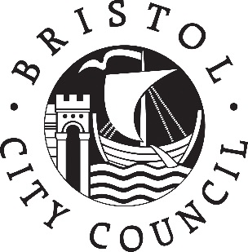

Bristol City Council – Early Years Contacts – October 2020

The Early Years Team are continuing to work from various locations around the city and some from home, so if you need to contact us please use the table below. If there isn’t a specific telephone number, you can email to request a call back.
Team or Person | Email Addresses | Telephone Numbers
Dawn Butler – General Enquiries & SEND | Dawn.Butler@bristol.gov.uk | 07827 306287
Nicola Theobald - General Enquiries & Nursery School Enquiries | Nicola.Theobald@bristol.gov.uk | 07827 992760
Deborah Brown - General Enquiries | Deborah.Brown@bristol.gov.uk | 07827 348719
Childminding Support | cmsupport@bristol.gov.uk | 07825 106678 – Sharon McDonald  07884 735983 – Joanne Dennis  07880 042575 – Rachel Landen  07443 753909 – Julia Harkess  07786 660809 – Lucy Dale
Family Information Service | askcyps@bristol.gov.uk | 0117 3574192
Foundation Years Consultants | Smiljana.pearce@bristol.gov.uk  Beth.osborne@bristol.gov.uk  Kate.hubble@bristol.gov.uk  Nicky.bale@bristol.gov.uk | 07795 446577 – Smi Pearce  07880 070023 – Beth Osborne  07880 070011 - Kate Hubble  07880 447137 – Nicky Bale
Bristol Standard | BristolStandard@bristol.gov.uk | If you require a call back from this team, please email your name, contact number and brief query, requesting a phone call.  Be mindful to use Send Secure / Proofpoint if you include child level data!
EY SEN Panel Referrals, Reviews and Enquiries  Bristol Autism Team Referrals  Educational Psychology Referrals  Portage and Inclusion Referrals | earlyyears.senpanel@bristol.gov.uk  sarah.swann@bristol.gov.uk
Eligible 2 Year Old Applications | twoyearolds@bristol.gov.uk
2 Year Old Payments | eyclaims@bristol.gov.uk
3 & 4 Year Old Payments, EYPP and DAF
30 Hours | 30hours@bristol.gov.uk
Enhanced Provision Payments | childminder.payments@bristol.gov.uk
Enhanced Provision Referrals | eyenhancedprovision@bristol.gov.uk

